**JAVA LAB FILE**

**Program in java to print the java programming**.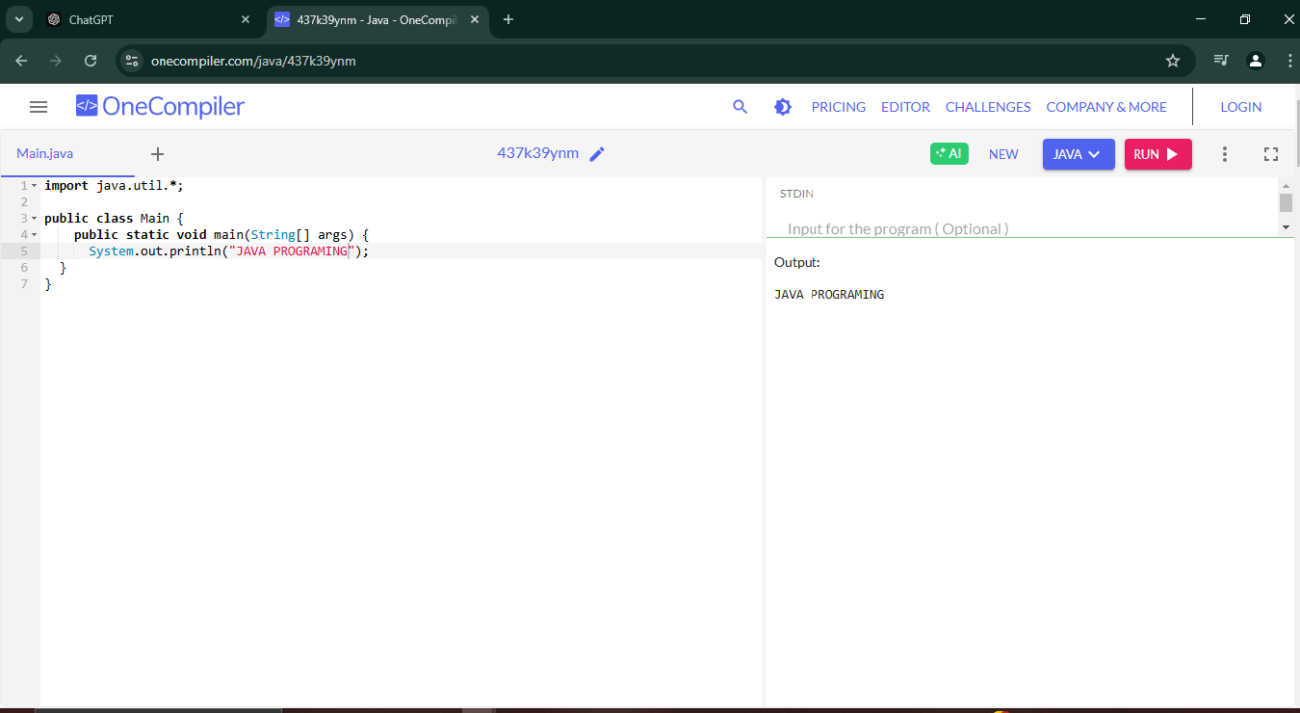

**Q1**.**Average and sum of three numbers**

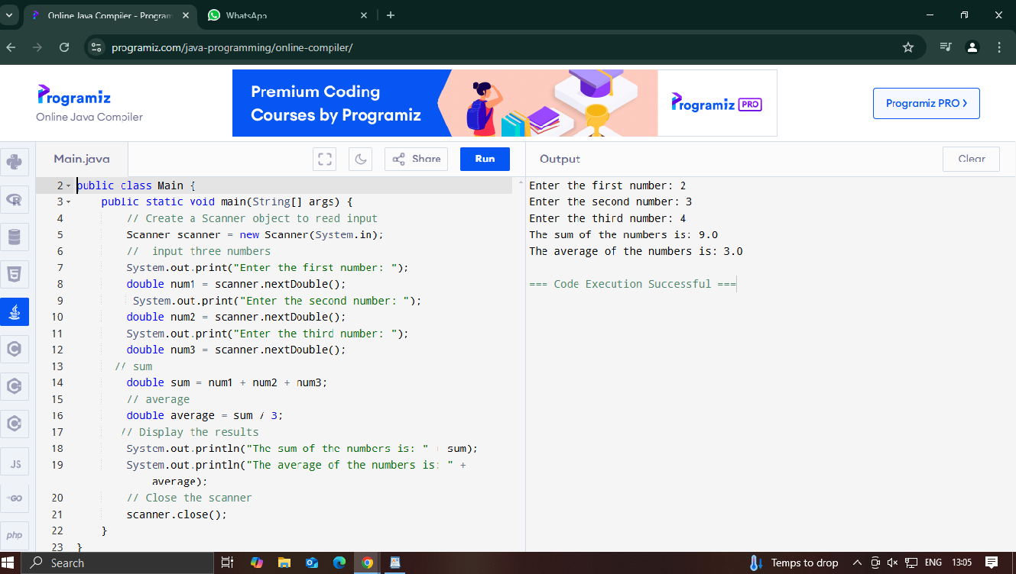

**Q2.WAP to demonstrate type casting**

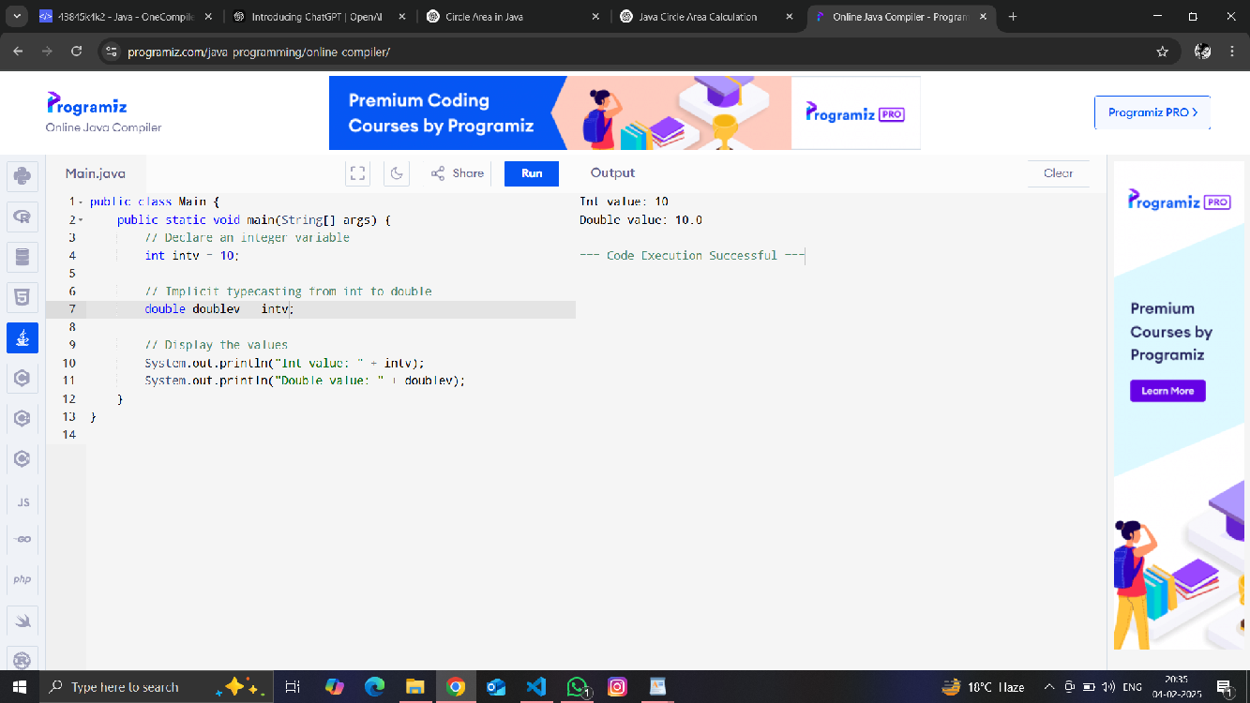

**Q3.Write a program to generate prime numbers between 1 & given number**

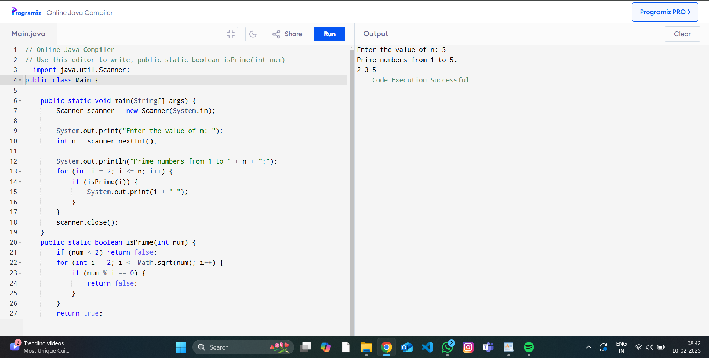

**Q4.Pyramid of stars**

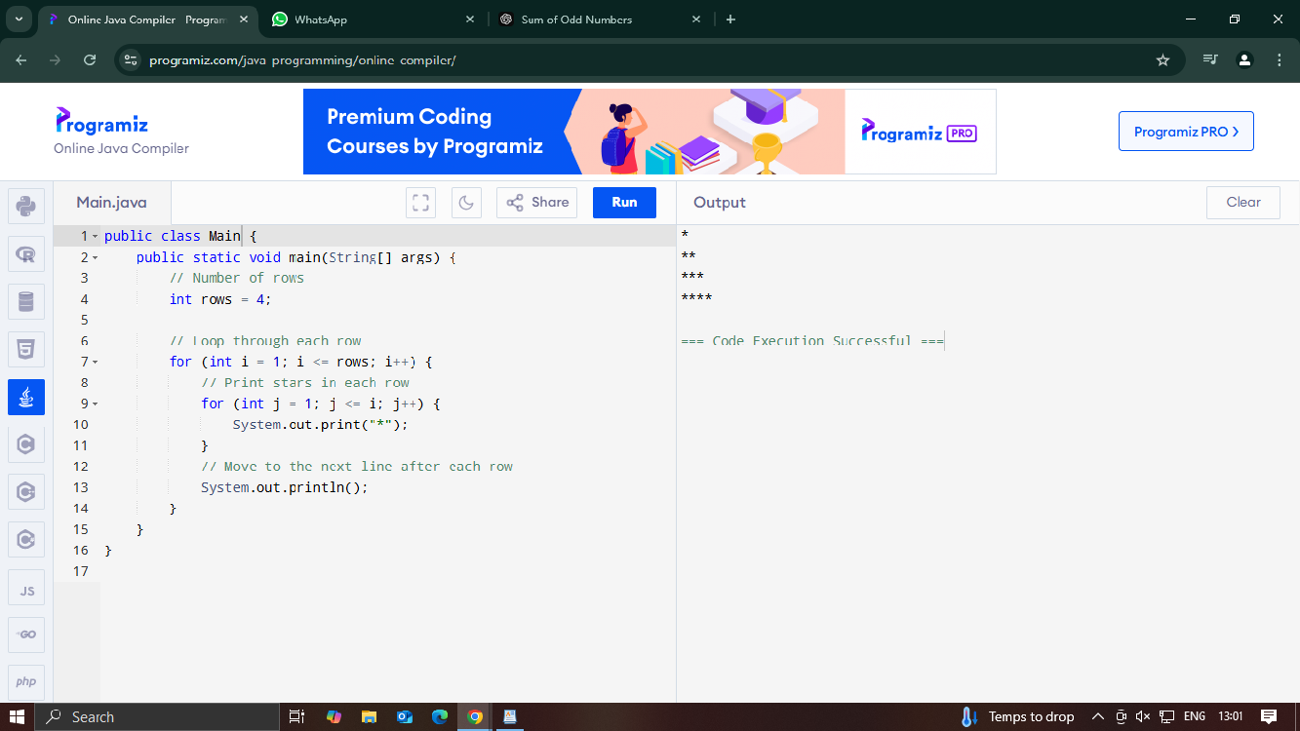

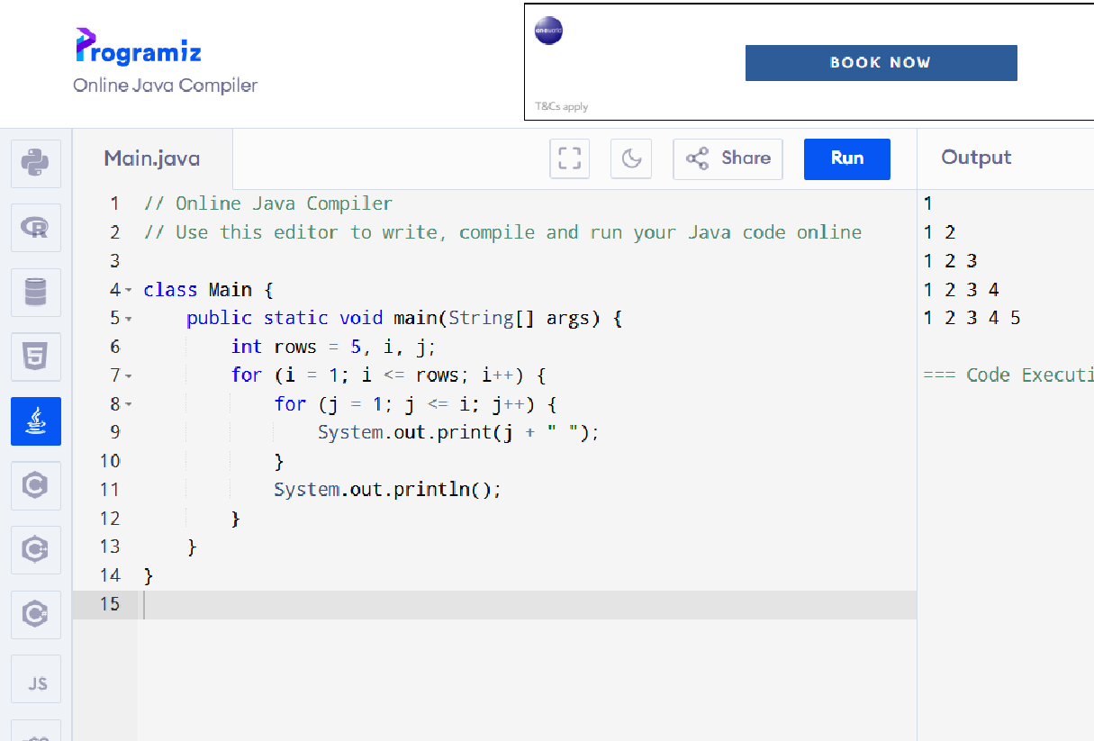

**Q5.Write a program to reverse pyramids using for loops & decrement operators.**

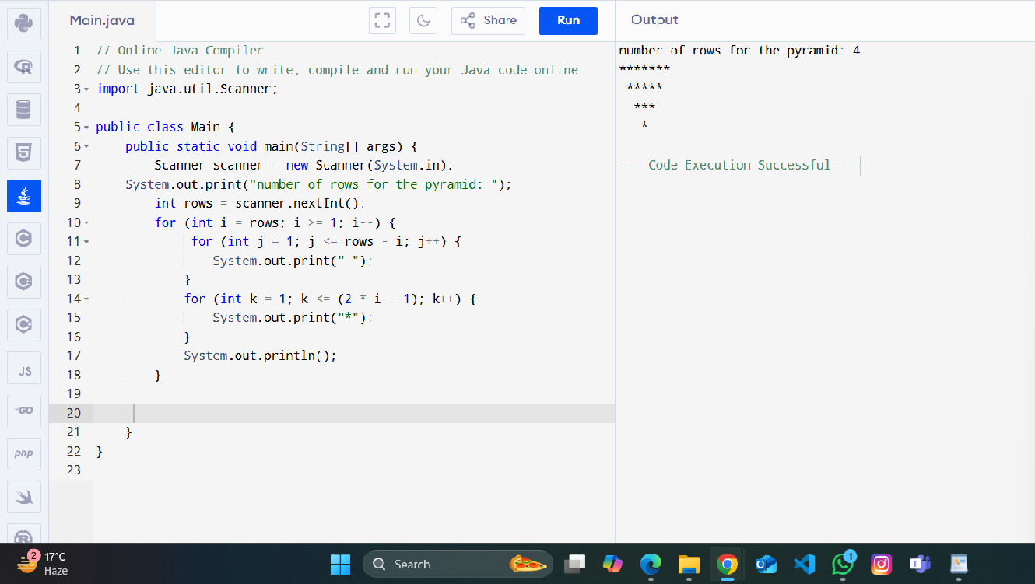

**Q6.Write a program for demonstrate Nested Switch**

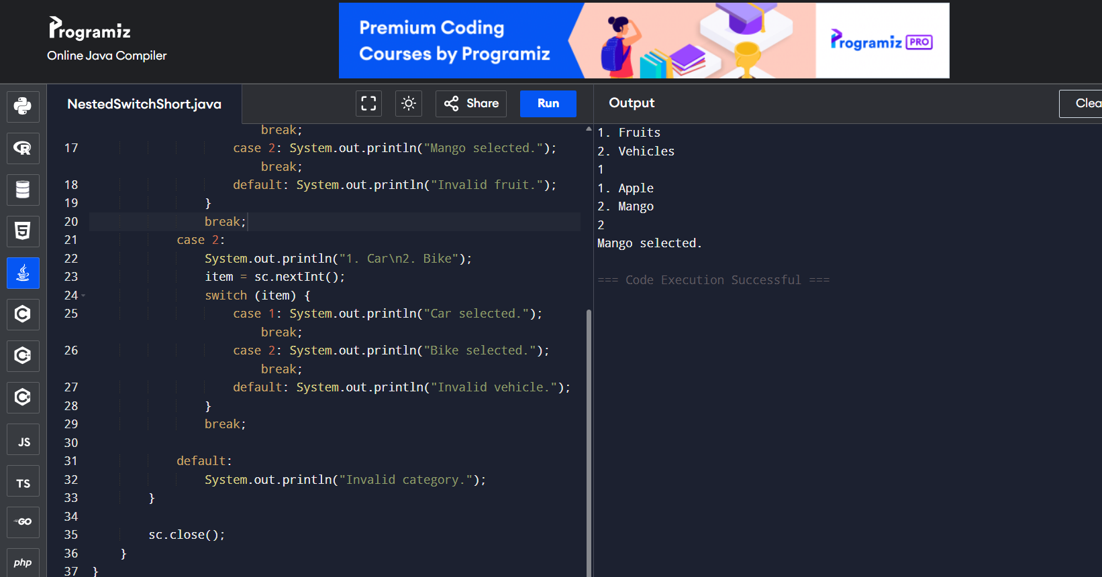

**Q7.Command line argument calculate area of circle**

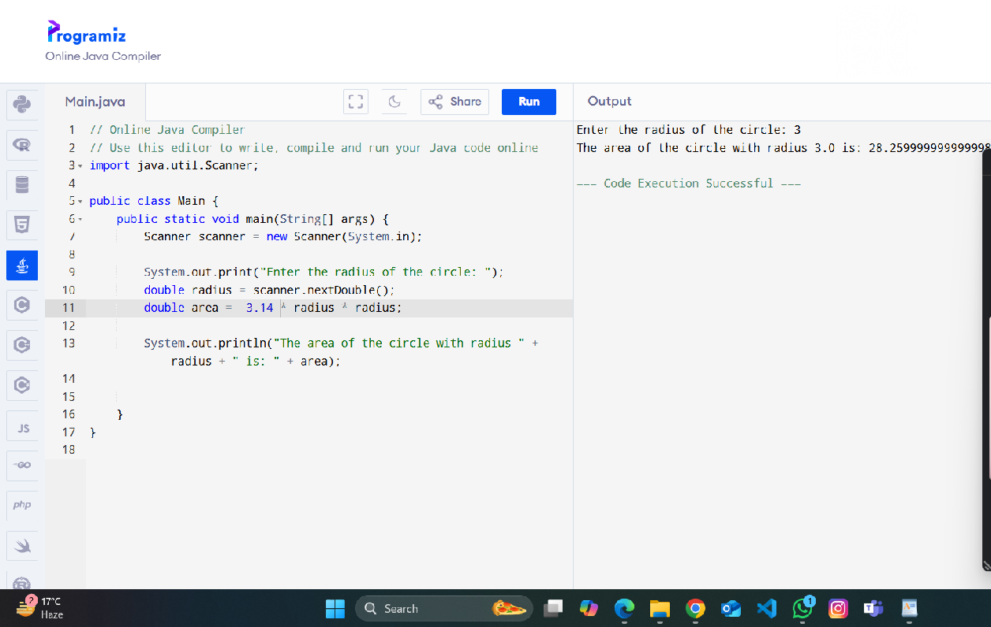

**Q8.Write a program to find G.C.D of the number.**

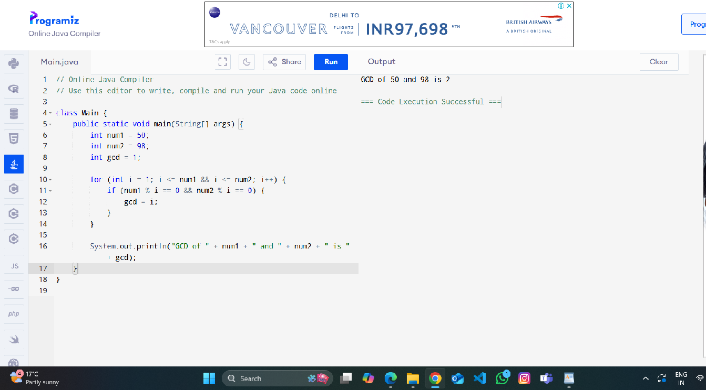

**Q9.Write a program to design a class account using the inheritance and static members which show all functions of a bank (Withdrawal, deposit)**

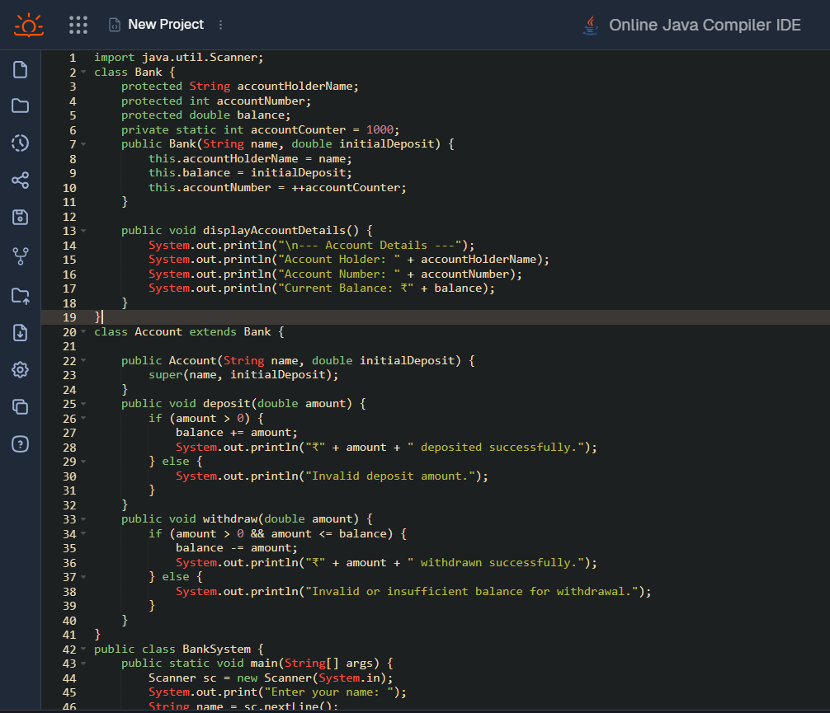

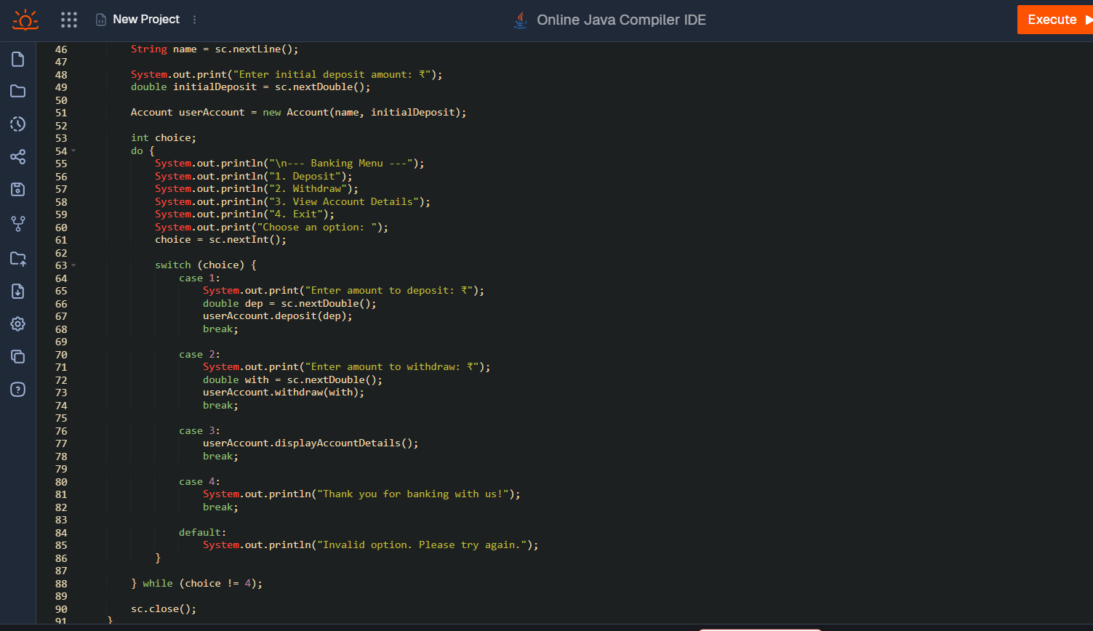

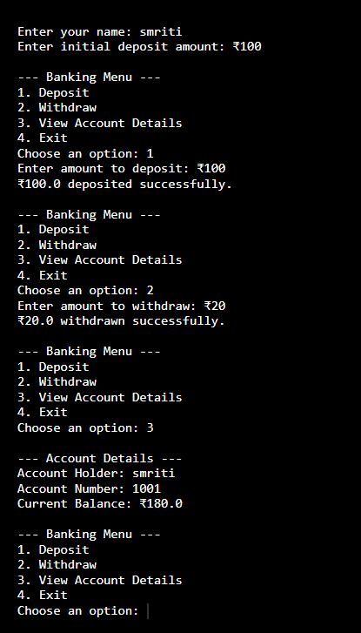

**Q10.Write a program to create a simple class to find out the area and perimeter of a rectangle using super and this keyword**.

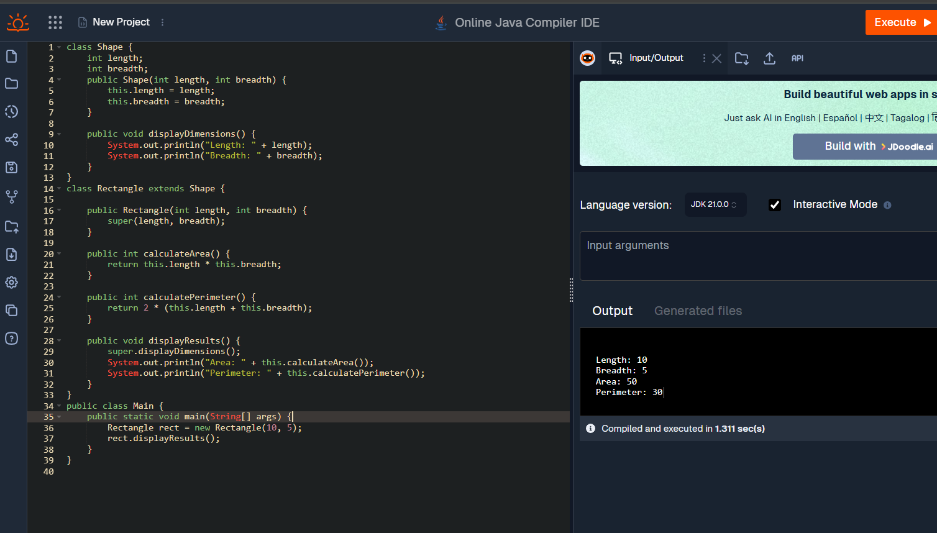

**Q11.Write a program to find the factorial of a given number using recursion.**

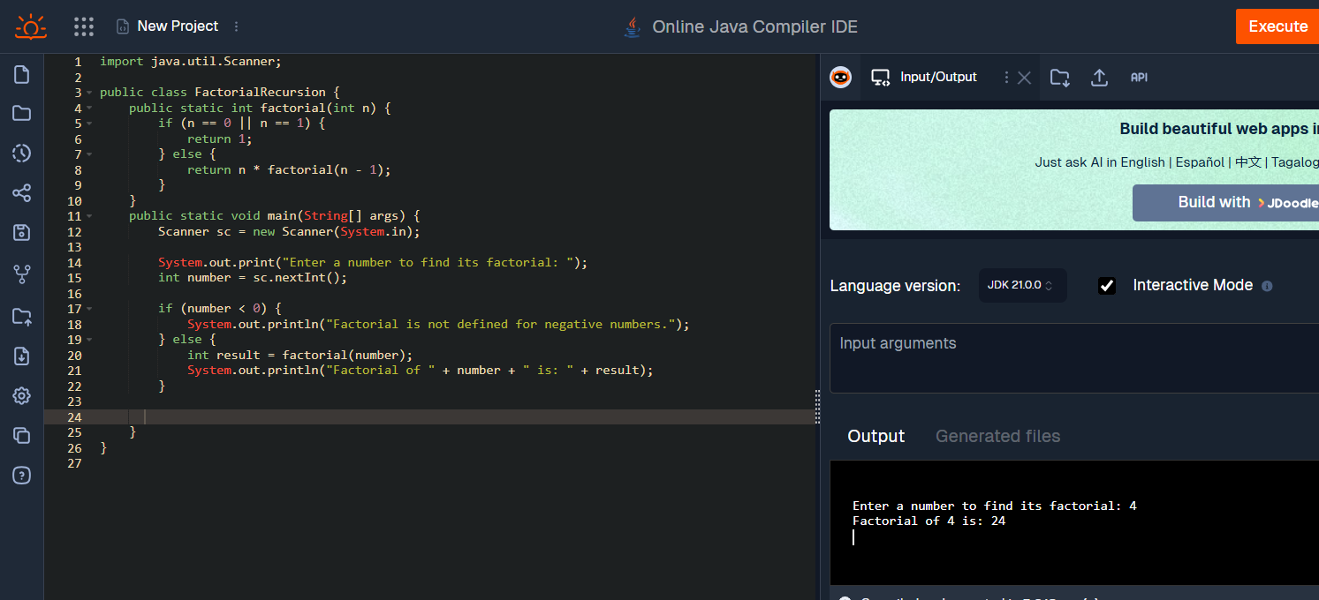

**Q12.Write a program to design a class using abstract methods and abstract classes.**

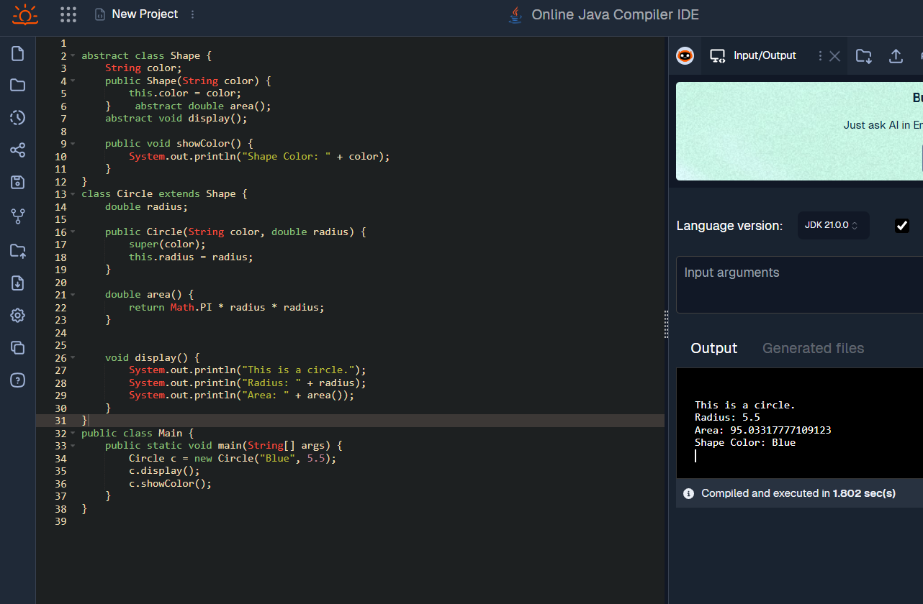

**Q13.Write a program to count the number of objects created for a class using static member function.**

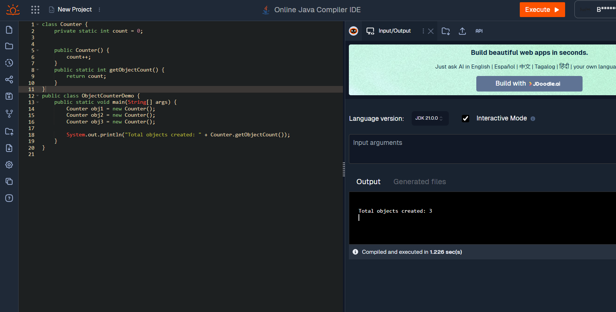

**Q14.Write a program to demonstrate the use of function overloading.**

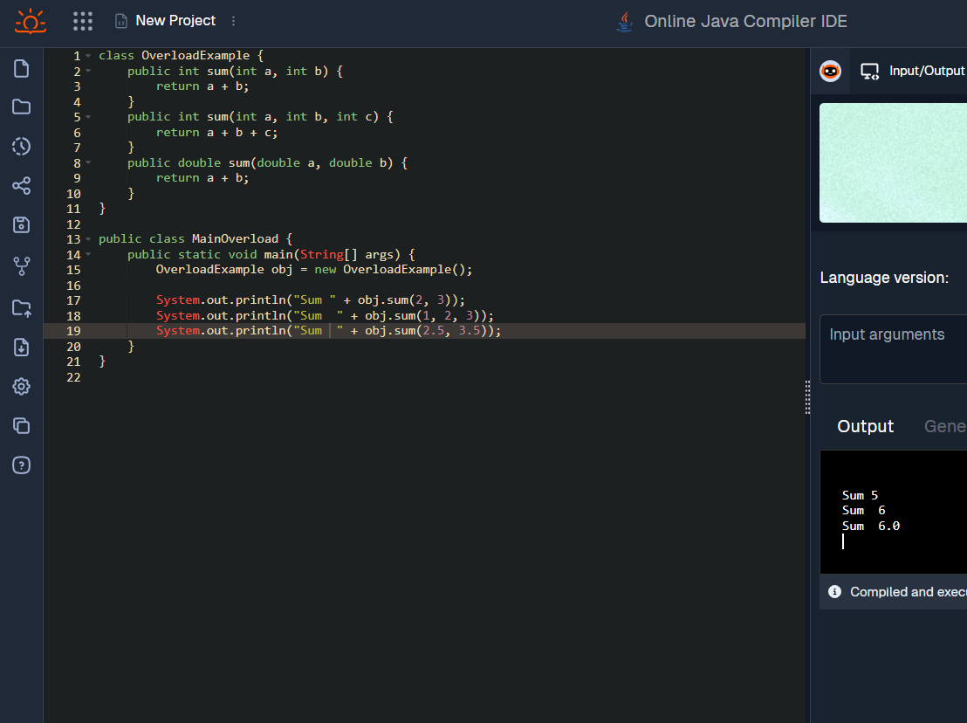

**Q15.Write a program to demonstrate the use of inheritance**

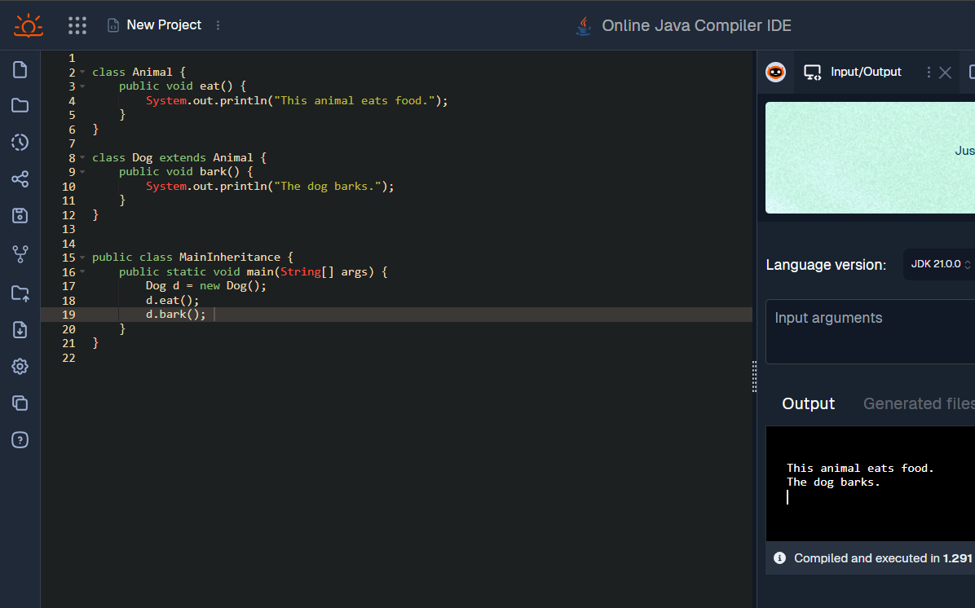

**Q16.Write a program that show the partial implementation of Interface**

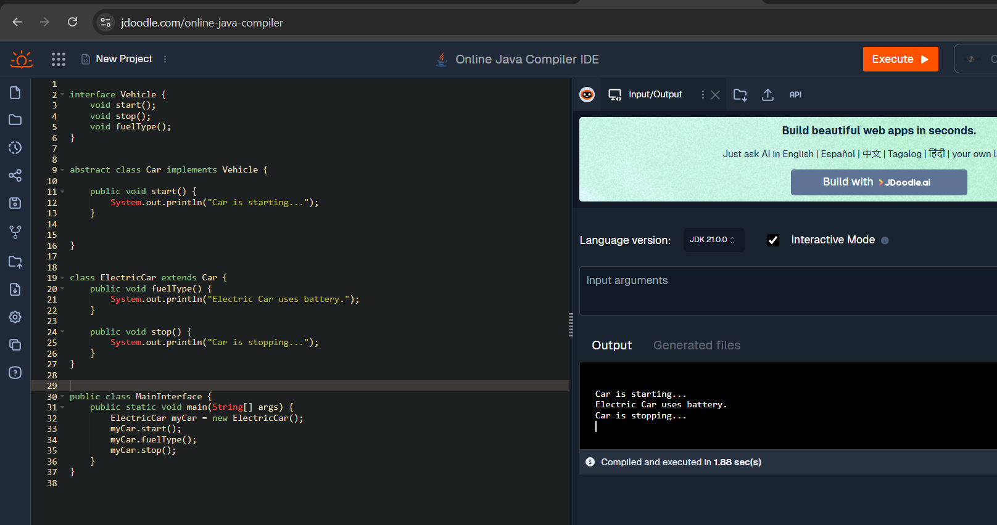

**Q17.Write a program to design a string class that performs the string method (Equal, Reverse the string, change case).**

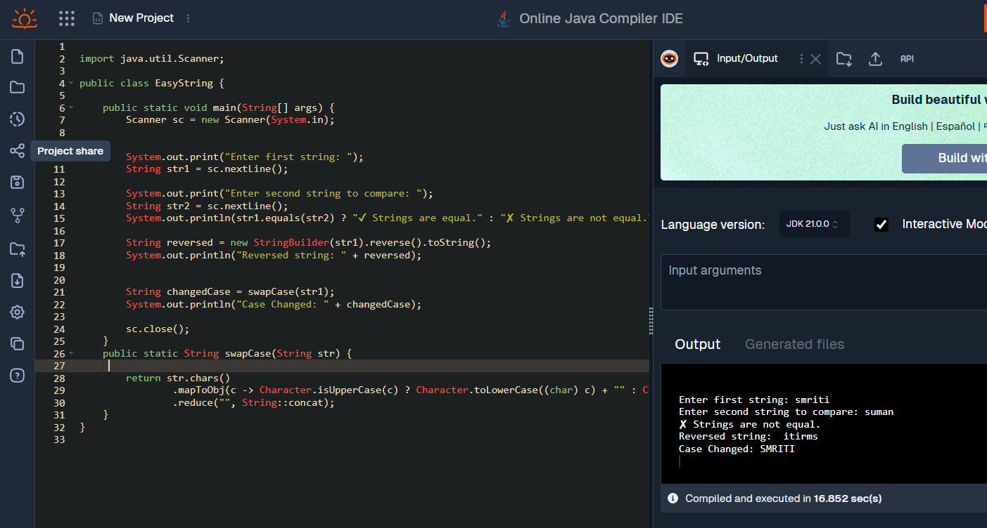

**Q18.Write a program to handle the exception using try and multiple catch blocks.**

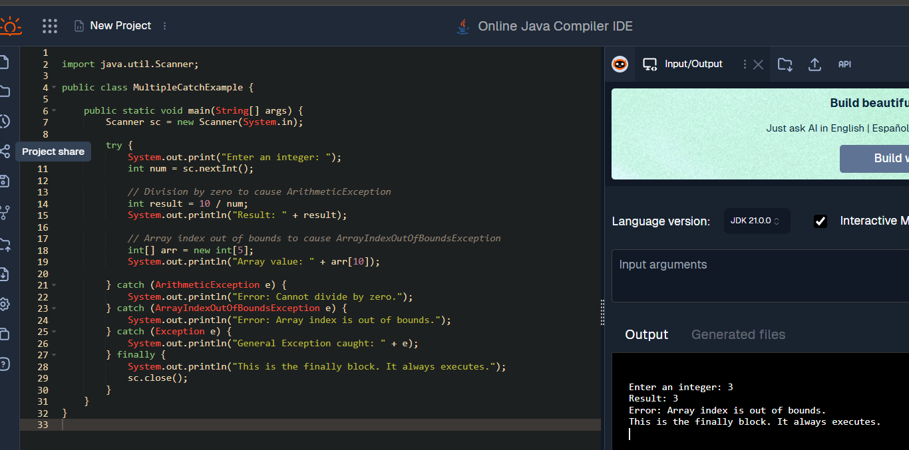

**Q19.Write a program that implements the Nested Try Statements**.

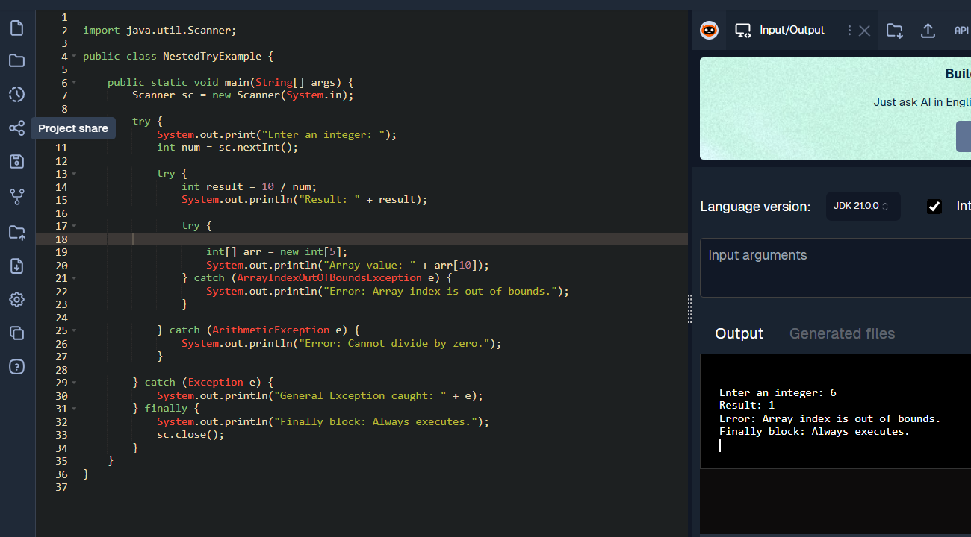

**Q20.Write a program to create a package that accesses the member of the External class as well as the same package.**

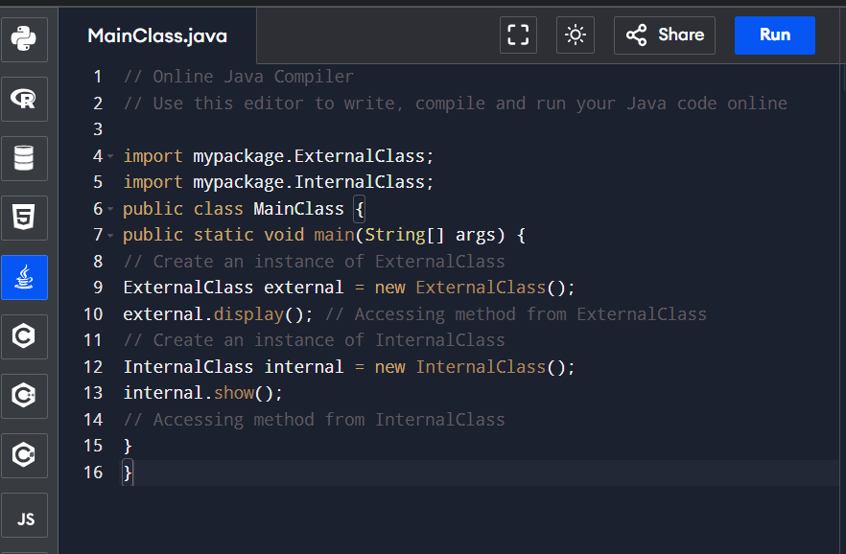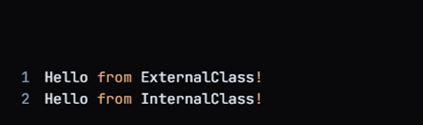

**Q21.Write a program to handle the user defined exception using throw keyword.**

